Product Definition
☑ No-brand Product | ◻ OEM/ODM Product
◻ Semi-finished Product | ◻ Component

SDCBA-C01
SDHC/SD/MMC to CardBus PC Card(32-bit)
High Speed Adapter

Specifications for Approval

Approval | Manager | Issued By

Revision History
Revision | Date | Description | PM
1.0 | January, 2009 |  | PHIL

Index
1 Introduction 1
2 Features and Specifications 2
2.1 Features 2
2.2 Specifications 3
2.3 Application Diagram 4
3 Accessories 5
3.1 Standard Accessories 5
3.2 Optional Accessories 5
4 Mechanical Information 6
4.1 SDCBA-C01 Overview 6
4.2 PCB Overview 7
5 Test Report 9
6 Package 10
6.1 Front & Back Labels 10
6.2 Serial Number Definition 10
7 Safety Certificate 11
Appendix 12

- Introduction

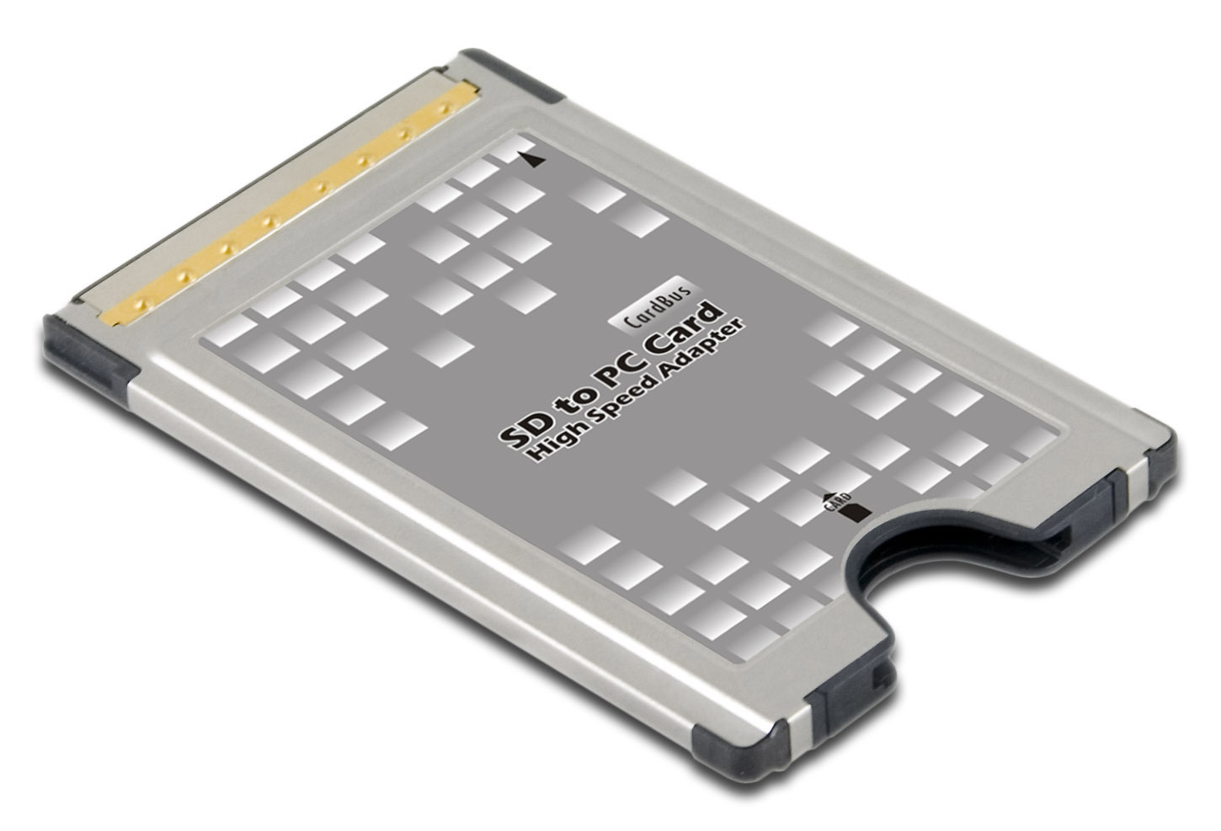

SHINLY Plastics corporation / POLU industrial Ltd proudly presents you a perfect solution for accessing the SDHC (Secure Digital High Capacity) / SD (Secure Digital) / MMC (MultiMediaCard) via 32-bit CardBus interface with a higher speed.

This adapter supports converting SD, SDHC, miniSD (with adapter), microSD (with adapter), microSDHC (with adapter), MMC, RS-MMC (with adapter), MMC Plus, and MMC Mobile (with Adapter) to Type II CardBus PC Card. A Push-Push socket is equipped for easy insertion/extraction of supported cards.

SDCBA-C01 is also compliant with SDIO specification, which allows you to use SDIO card with all kinds of applications on your computer.

SDCBA-C01 is a very convenient and high speed SDHC/SD/MMC card adapter/reader for any computer equipped with 32-bit CardBus socket. If you are tired of using the card reader with a slow speed, you should absolutely try SDCBA-C01; just contact SHINLY Plastics corporation / POLU industrial Ltd now!

- Features and Specifications
  - Features
- Compliant with 32-bit CardBus Type II PC Card interface (JEIDA 4.2). Maximum frequency reaches 33MHz.
- Compliant with SD Memory Card Specification 2.0.
- Supports SDHC / High Speed SD Clock (50MHz)
- Compliant with SDIO Specification 1.1.
- Supports all kinds of SDIO Card Applications.
- Compliant with SD Host Controller Standard Specification 1.0.
- Compliant with MultiMediaCard Specification 4.1.
- Supports MMC Plus and MMC Mobile (with adapter.).
- Push-Push card slot for easy insertion/extraction of card.
- Low power consumption, 3.3V single power operation.
- Software Suspend mode compliant with ACPI.
- Supports Hardware Suspend.
  - Specifications
Input Socket
Single Socket  (Push-Push) | - SDHC / SD (SD Specification 2.0)  - SDIO (SDIO Specification 1.1)  - MMC (MMC Specification 4.1)
Output Interface
32-bit CardBus Type II PC Card
Supporting Memory Cards
SDHC |  | - 4GB~
SD |  | - 8MB~2GB
miniSD |  | - 8MB~2GB (Adapter Required)
microSDHC |  | - 4GB~ (Adapter Required)
microSD |  | - 8MB~2GB (Adapter Required)
MMC / MMC Plus |  | - All Capacities
RS-MMC / MMC Mobile |  | - All Capacities
Controller
RICOH R5xxxx
Supporting OS
Microsoft Windows XP / VISTA
Safety Approval
CE / FCC
Physical Character
Length | - 85.0 mm
Width | - 54.0 mm
Height | - 5.0 mm
Weight

  - Application Diagram

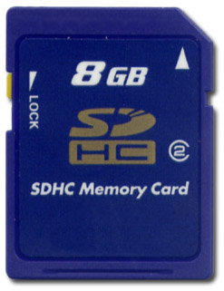
SDHC

Desktop
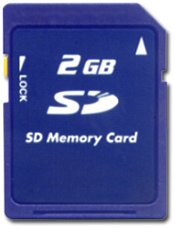
SD


SDCBA-C01

CardBus Interface
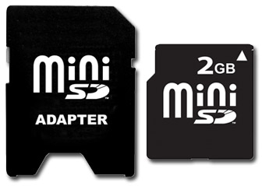
miniSD+Adapter

Notebook

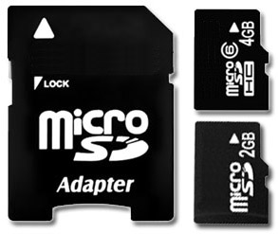
microSD/SDHC
+Adapter

- Accessories
  - Standard Accessories

- SDCBA-C01 Adapter x1

  - Optional Accessories

- Front Label x1
- Back Label x1
- Mechanical Information
  - SDCBA-C01 Overview

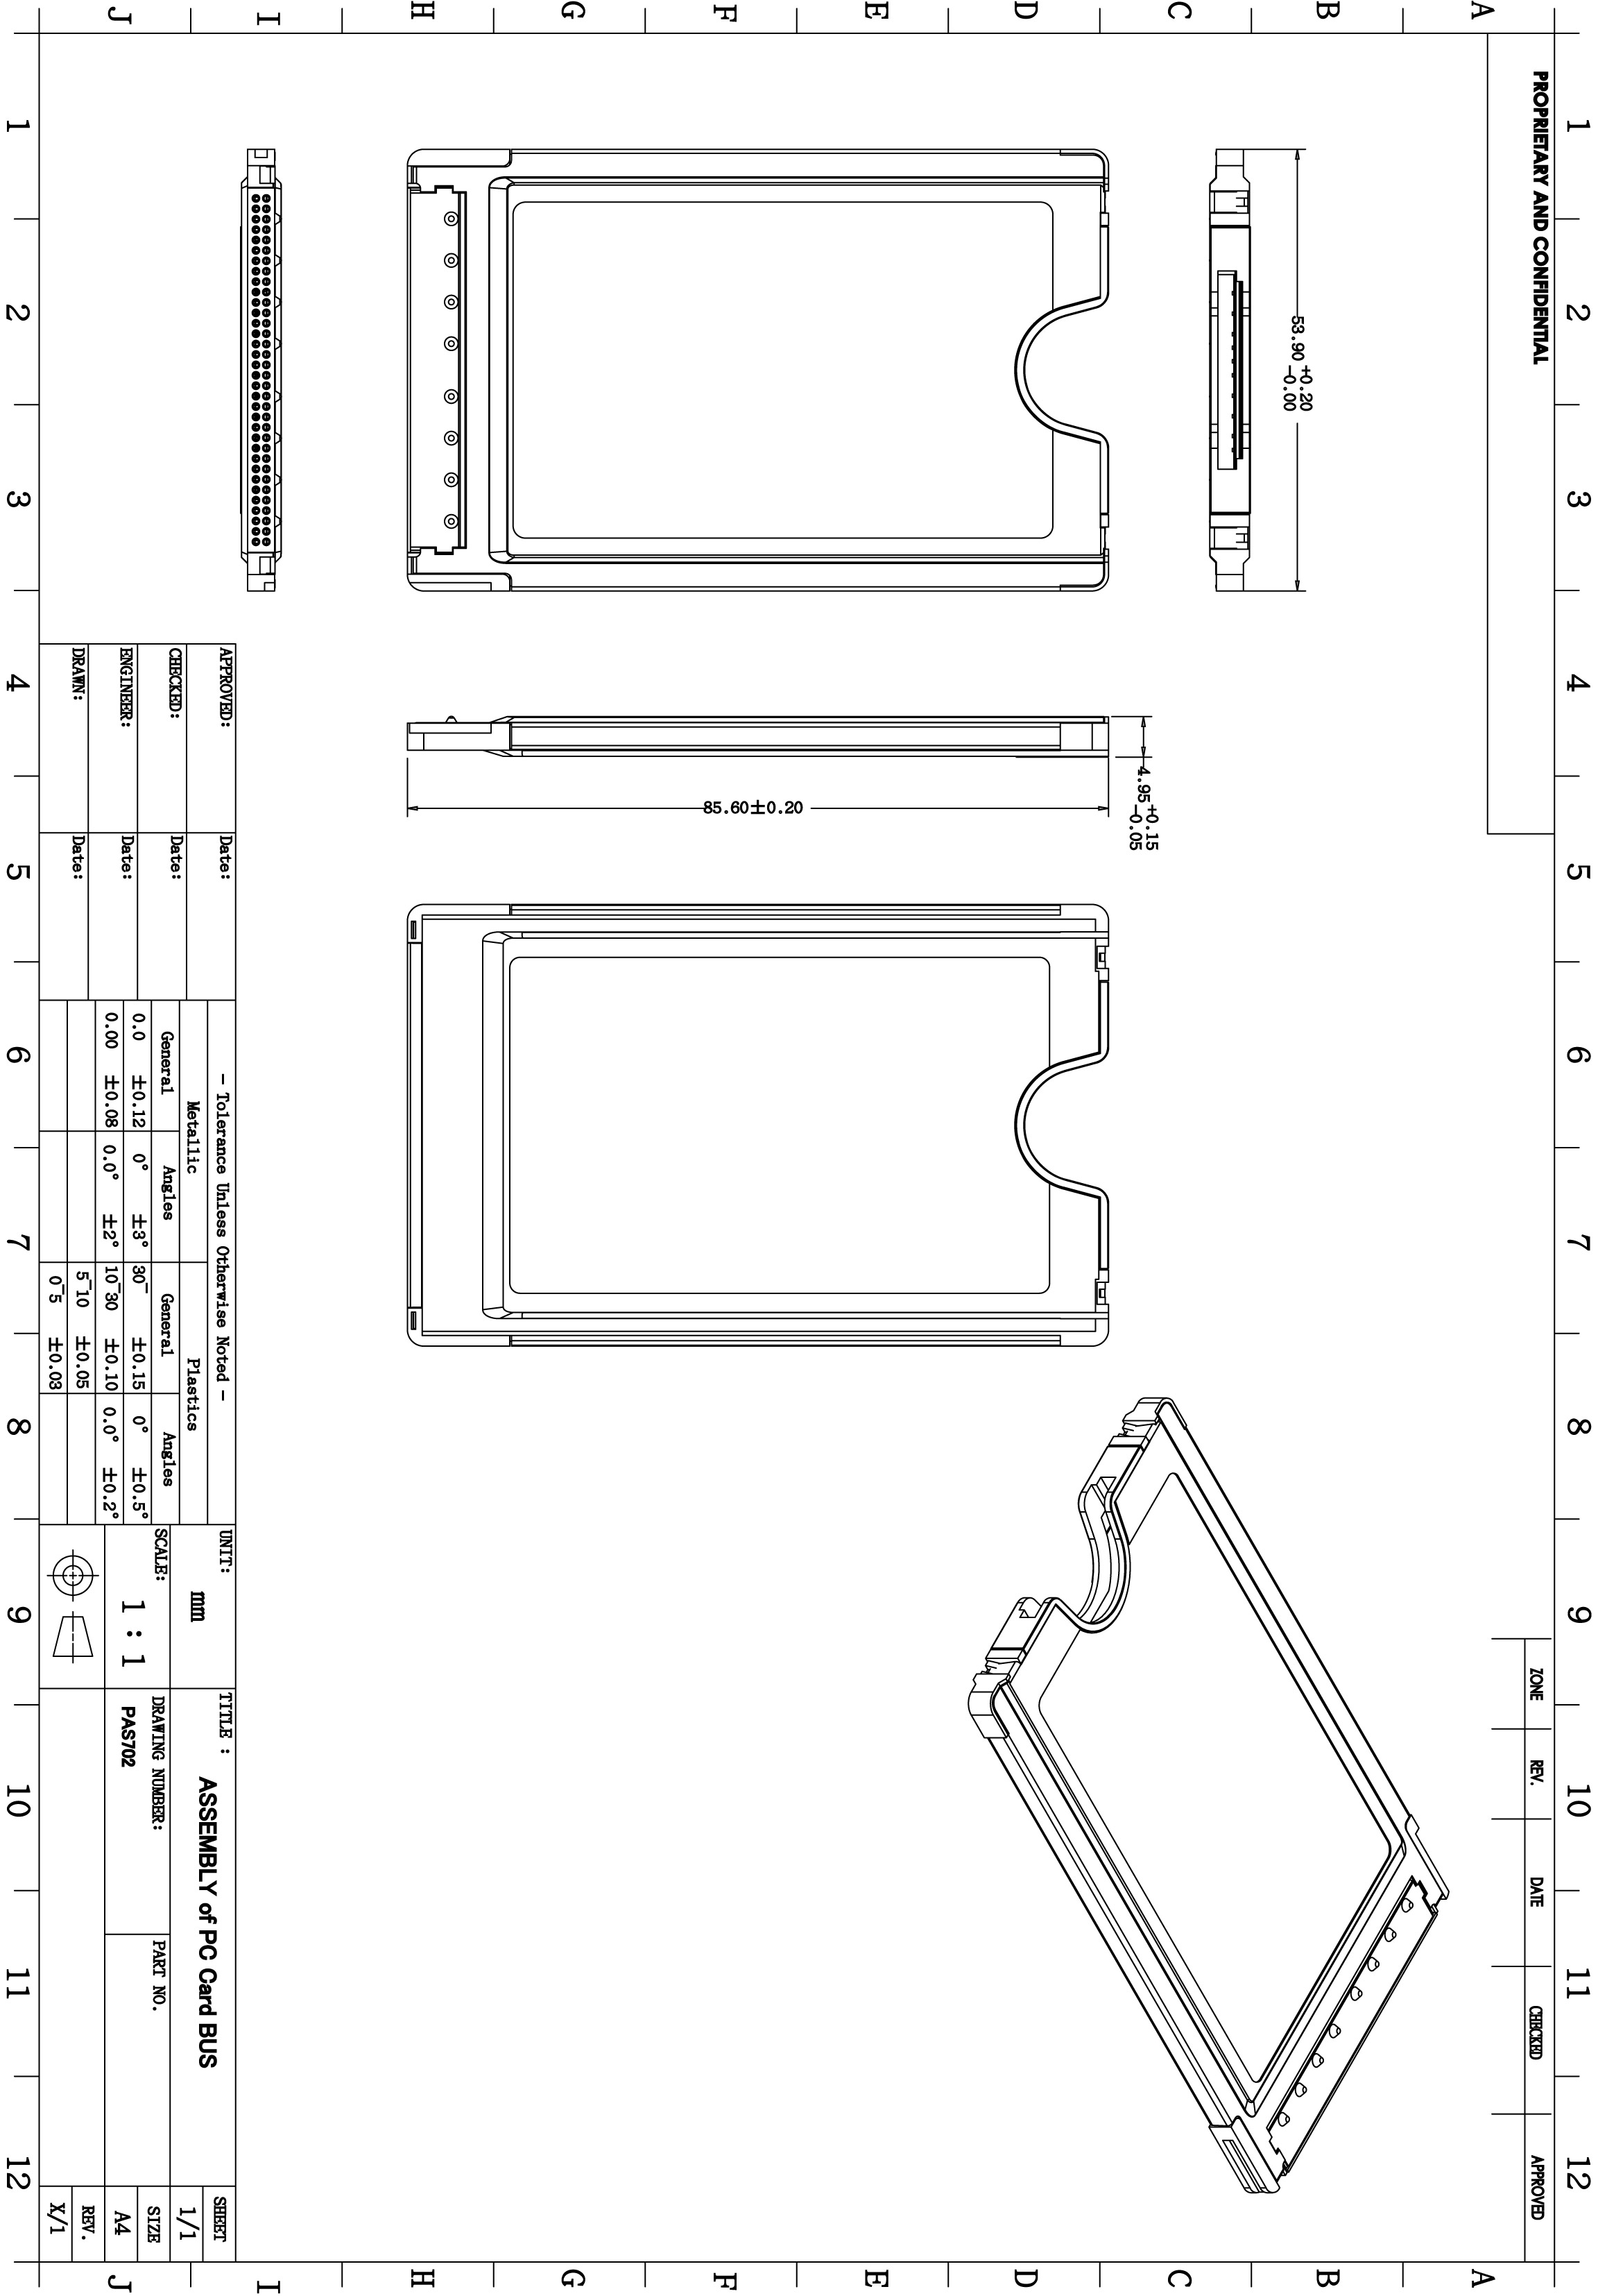
  - PCB Overview

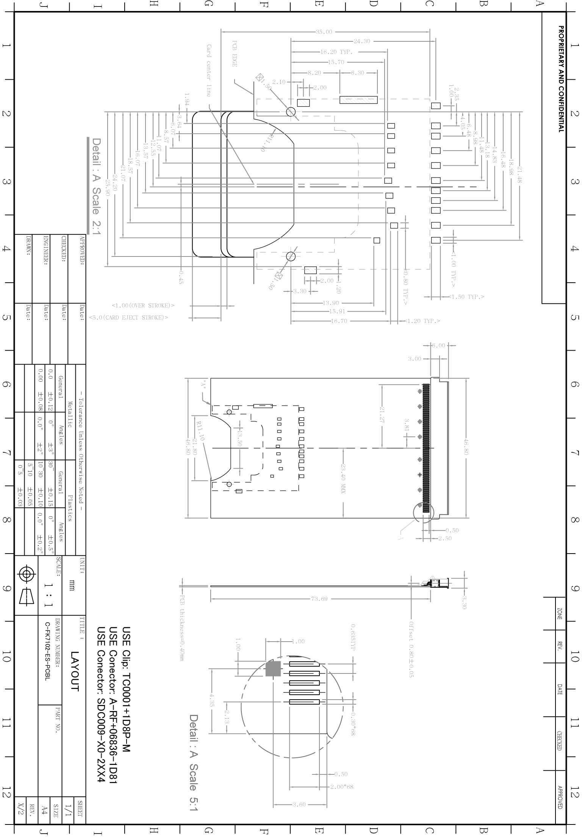
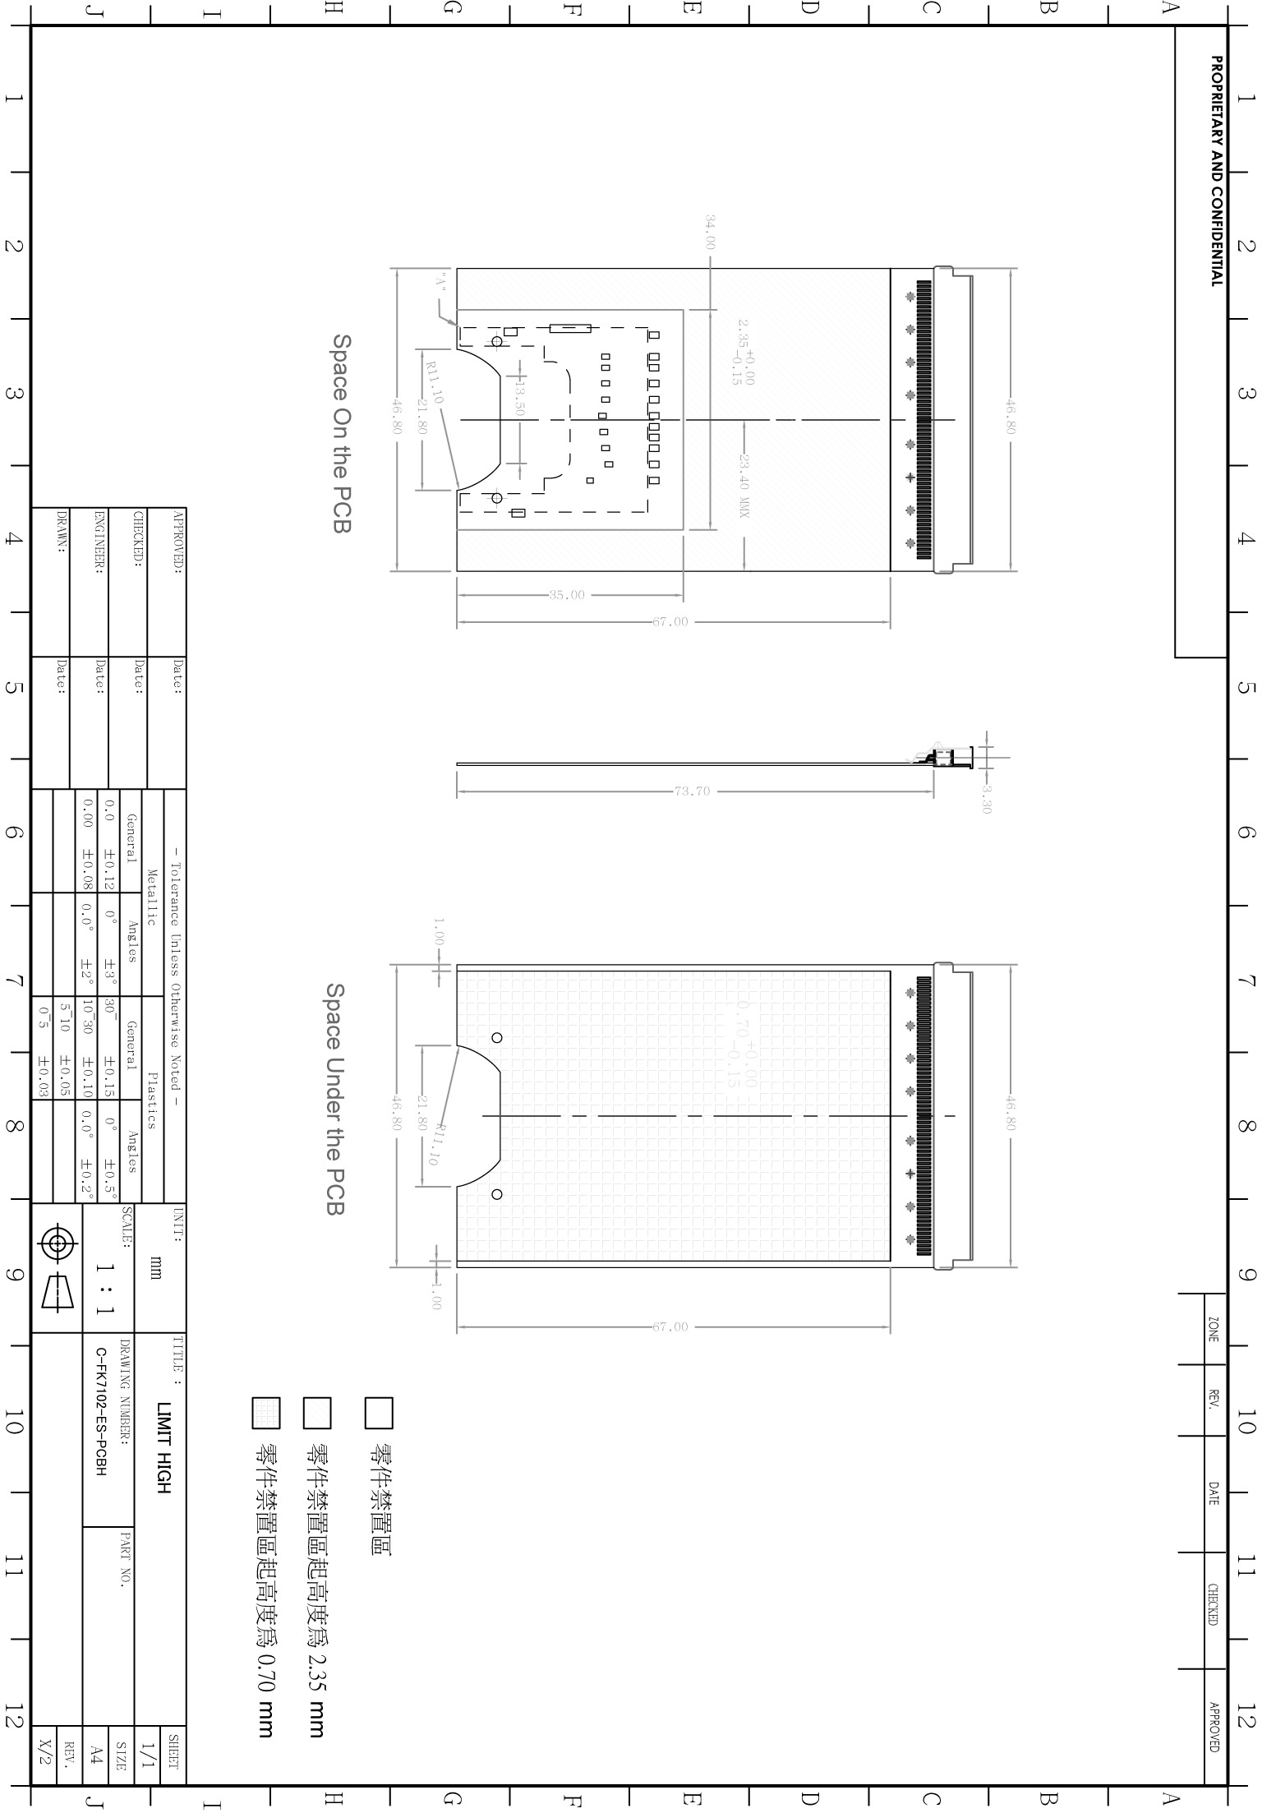
- Test Report
Test Device | CM SDCBA-C01 CardBus Adapter
Test Hardware | ASUS Notebook W3A
System memory | 2GB
Test OS | Microsoft WindowsXP Service Pack 3
Test Software | HDBENCH 3.4
Test Card | Read Speed | Write Speed | Random Read Speed | Random Write Speed
PhotoFast_DualChannel_SDHC_150X_4GB | 22908 | 8855 | 20475 | 2293
SanDisk_Extreme_ESP_SDHC_class6_4GB | 22831 | 16179 | 20098 | 4836
SanDisk_Extreme_ESP_SDHC_class6_8GB | 23151 | 16060 | 20039 | 4765
SanDisk_Extreme_SDHC_class6_4GB | 23073 | 13511 | 20537 | 2290
SanDisk_Extreme_SDHC_class6_8GB | 23068 | 13765 | 20475 | 2333
SanDisk_Extreme_SDHC_class6_16GB | 23068 | 13566 | 20475 | 2306
SanDisk_SDCard_class2_2GB | 11680 | 5903 | 10672 | 1281
SanDisk_SDHCCard_class2_4GB | 11640 | 5315 | 10654 | 1086
SanDisk_SDHCCard_class2_8GB | 11619 | 5375 | 10654 | 1082
SanDisk_UltraII_SDHC_class4_4GB | 17902 | 14994 | 16179 | 4728
SanDisk_UltraII_SDHC_class4_8GB | 17852 | 14559 | 16060 | 4654
SanDisk_UltraII_SDHC_class4_16GB | 17805 | 14793 | 16100 | 4563
SanDisk_videoHD_SDHC_class4_8GB | 11681 | 9524 | 10885 | 3796

- Package
  - Front & Back Labels
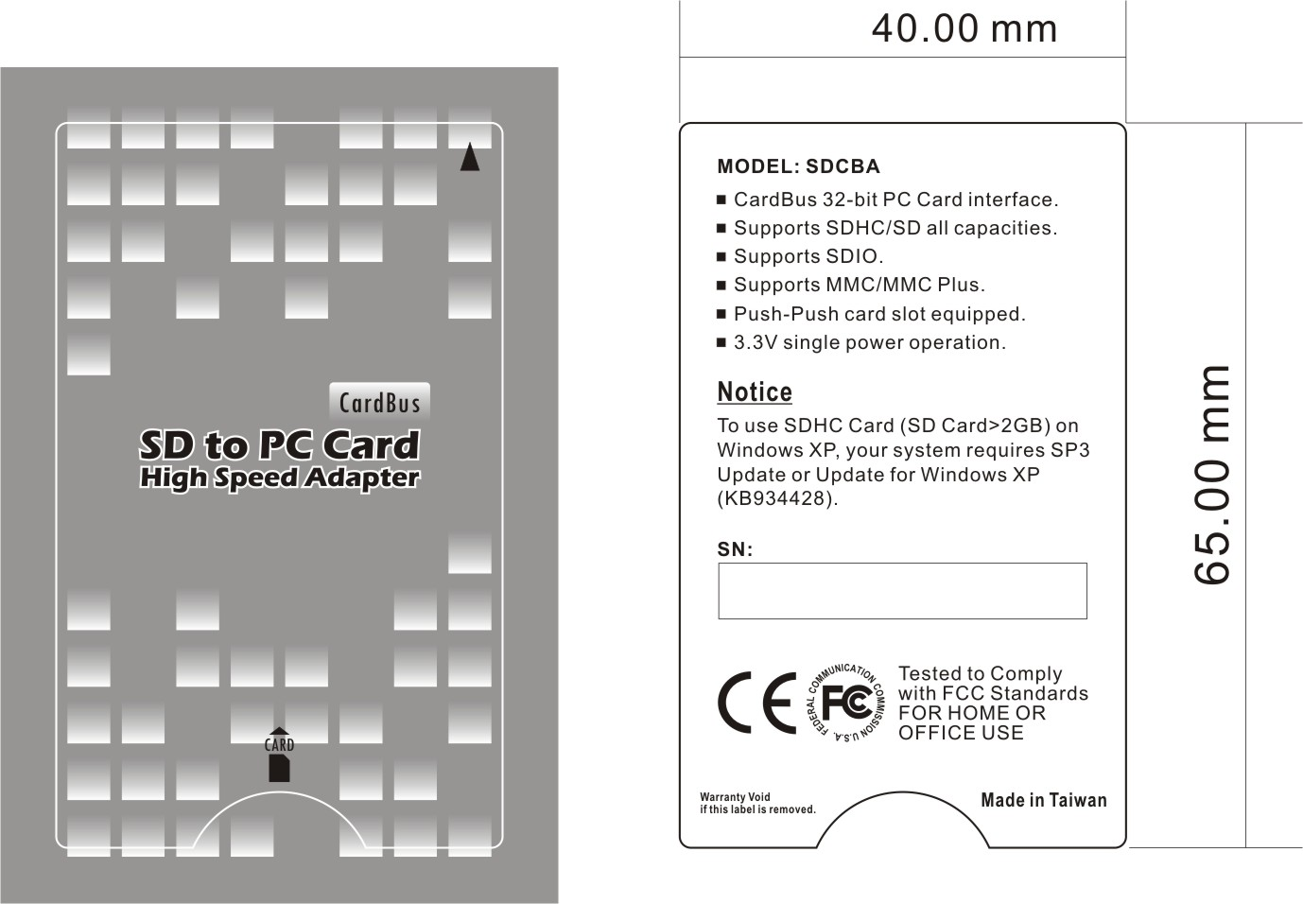

  - Serial Number Definition

C01 09 000001

Product Version Year of Production Serial Number

- Safety Certificate

Appendix

